Order Of Service

Singing: Psalm 130—CW page 114

Reading: Psalm 58

Opening Hymn: TLH 42

Reading: Acts 6:8-15

Request Hymn: CW Supplement 748

Reading: John 13:21-30

Sermon Hymn: TLH 352

Sermon Text: Song Of Solomon 8:11-12

Two Vineyards

Prayer

The Apostles’ Creed, TLH page 12

Holy Communion

The Lord's Prayer

The Blessing

Closing Hymn: TLH 355

* * * * * * * * * * *

Bible Study: Lambs: Fox
Sheep: Romans 5:12-21
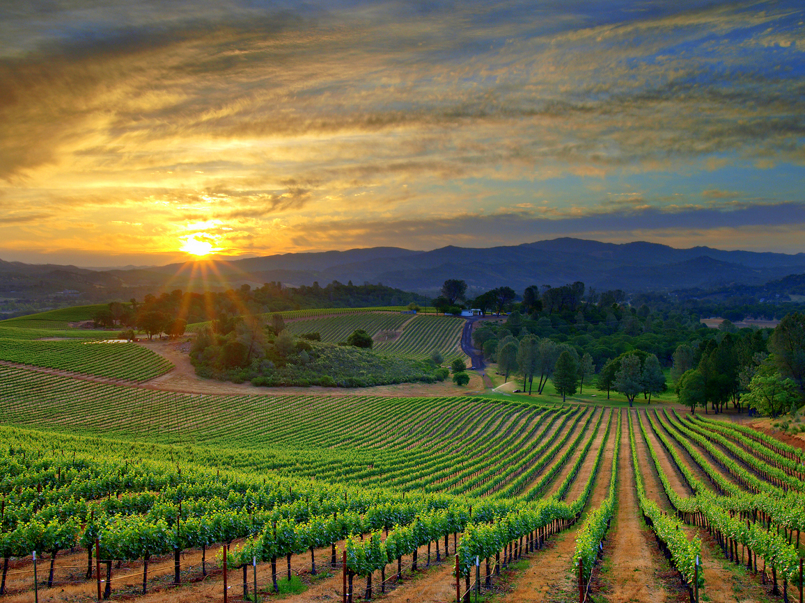

Two Vineyards

Water
Of
Life

15 October 2017

W A T E R O F L I F E

Independent Christian Church—Conservative Lutheran Doctrine

Worship Service: 9:30 a.m. Bible Study: 10:45 a.m.

Larry Cooper, Pastor E-Mail address:
111 N. Ridge Road lcooper@wateroflife.cc
Coon Valley, WI 54623 Web Site:
Phone: (608) 452-2105 www.wateroflife.cc

* * * * * * * * * * * * * * * * * * * * * * * * * * *

Sermon Text: Song Of Solomon 8:11-12

Two Vineyards

* * * * * * * * * * * * * * * * * * * * * * * * * * *

Song of Solomon 8:11 Solomon had a vineyard at Baalhamon; he let out the vineyard unto keepers; every one for the fruit thereof was to bring a thousand pieces of silver.
:12 My vineyard, which is mine, is before me: thou, O Solomon, must have a thousand, and those that keep the fruit thereof two hundred.

Related Readings—Isaiah 5:1-7

1 Now will I sing to my wellbeloved a song of my beloved touching his vineyard. My wellbeloved hath a vineyard in a very fruitful hill:
2 And he fenced it, and gathered out the stones thereof, and planted it with the choicest vine, and built a tower in the midst of it, and also made a winepress therein: and he looked that it should bring forth grapes, and it brought forth wild grapes.
3 And now, O inhabitants of Jerusalem, and men of Judah, judge, I pray you, betwixt me and my vineyard.
4 What could have been done more to my vineyard, that I have not done in it? wherefore, when I looked that it should bring forth grapes, brought it forth wild grapes?
5 And now go to; I will tell you what I will do to my vineyard: I will take away the hedge thereof, and it shall be eaten up; and break down the wall thereof, and it shall be trodden down:
6 And I will lay it waste: it shall not be pruned, nor digged; but there shall come up briers and thorns: I will also command the clouds that they rain no rain upon it.
7 For the vineyard of the LORD of hosts is the house of Israel, and the men of Judah his pleasant plant: and he looked for judgment, but behold oppression; for righteousness, but behold a cry.

Matthew 21:33-46

37 But last of all he sent unto them his son, saying, They will reverence my son.
38 But when the husbandmen saw the son, they said among themselves, This is the heir; come, let us kill him, and let us seize on his inheritance.
39 And they caught him, and cast him out of the vineyard, and slew him.

